DONNA
STROUPE

G r ap h i c D e s i g n e r
A graphic designer is a professional within graphic design and graphic arts industry assembles images, typography or motiongraphics to create a piece design.


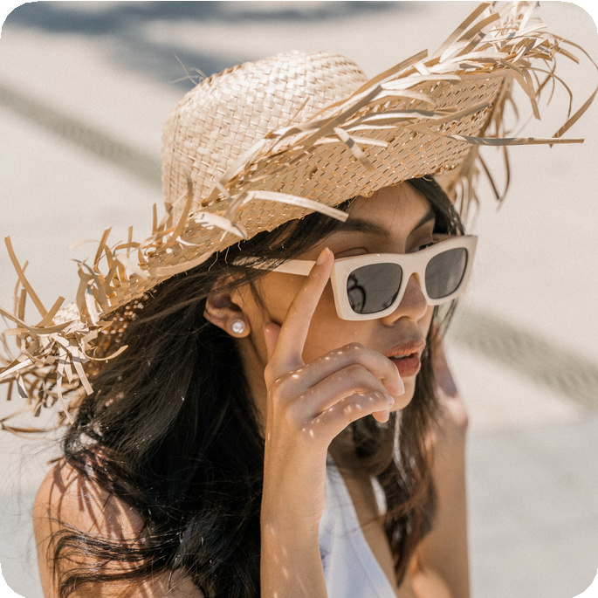 About Me
A graphic designer is professional within graphic design and graphic arts industry who assembles images, typography or motion graphics create a piece of
design.
Skills
Graphic Design Illustration Photography Motion Graphics Layout

Contact
+123-456-7890
hello@reallygreatsite.com www.reallygreatsite.com
123 Anywhere St., Any City, ST 12345

Education
SAN DIAS SCHOOL OF DESIGN, 2010
Visual Art
Graphic Design School for High School Website

BACHELOR OF ARTS, 2013
Graduated with Mention, 2016
BA Graphic Design and Visual Communication

Experience Work
GRAPHIC DESIGN
2021 / 2022 - Reallsite Studio
Tasked to make graphics for off line and offline layouts. Edited editorial photos for clients and magazines.

ART DIRECTION
2022 / 2023 - Reallsite Studio
Tasked to make graphics for off line and offline layouts. Works closely with the copywriting team. Concept and develop control beaters Edited editorial photos for clients and .

PROJECT MANAGER
2027 - Present | Reallsite Studio
Worked on marketing campaigns for different brands. Assisted the head designer in numerous projects Works closely with the copywriting team. Concept and develop control beaters Handled

DONNA
STROUPE
GRAPHIC DESIGNER

+123-456-7890
hello@reallygreatsite.com

123 Anywhere St., Any City, ST 12345



To whom it may concern

A cover letter allows you to professionally introduce yourself to a prospective employer. Your goal in writing your cover letter should be to encourage the employer to read your resume and consider you for a specific position.

Highlight your achievements, skills, experiences, and training that are relevant to the position you want to get. However, avoid simply repeating the information you included in your resume. Tailor your cover letter to each employer and job. Since you are applying for specific roles, give specific examples and events that demonstrate your ability to perform well if given the position.

Yes, you should maintain a professional air throughout the copy, however, an exceedingly formal tone may turn off those who read it. Remember to also show genuine enthusiasm for the job. You can think of it this way: it’s not a suit-and-tie event, but a smart casual gathering. Steer away from highly personal information and questions about the position. This includes talking about salary expectations and company benefits. Instead, reserve such inquiries for the actual interview.

Make sure you proofread your cover letter before sending it. There are various online tools that can help you catch minor grammatical or typographical errors. Additionally, make sure your cover letter is easy to read. Use a simple font like the one used here. Avoid walls of text, too. Dividing your letter into paragraphs makes it easy on the eyes and organizes the information you provide.

Donna
THE UNDERSIGNED

